
Sri Lanka Institute of Information Technology

SOFTWARE ENGINEERING PROJECT REPORT

METADATA

Project Title: Smart Event Management System
Project Domain: Web-Based Event Planning & Booking Platform
Group ID: SE-Y2-GROUP-05
Course Code: SE2030
Semester: Year 2 – Semester 1
Submission Date: 2026-03-15

Group Members:
1. Nadeesha Shalom | IT24100001
2. Tharindu Perera | IT24100002
3. Kavindu Silva | IT24100003
4. Isuri Fernando | IT24100004
5. Chamod Weerasinghe | IT24100005
6. Sanduni Jayawardana | IT24100006
1. INTRODUCTION

1.1 System Overview
The Smart Event Management System is a web-based platform designed to automate event planning, booking, vendor management, and financial tracking. The system connects event organizers, clients, vendors, and administrators through a centralized digital platform. It eliminates manual scheduling, reduces booking conflicts, and ensures efficient coordination between stakeholders.

1.2 Objectives

OBJ-01: Automate event booking and scheduling.
OBJ-02: Enable secure online payments.
OBJ-03: Provide role-based access control.
OBJ-04: Ensure real-time availability management.
OBJ-05: Provide centralized reporting dashboard.

1.3 Stakeholders and Assigned Members

Member 1 → Stakeholder: Client (Customer)
Member 2 → Stakeholder: Event Manager
Member 3 → Stakeholder: Vendor Manager
Member 4 → Stakeholder: Finance Officer
Member 5 → Stakeholder: System Administrator
Member 6 → Stakeholder: Support & Service Coordinator

2. MEMBER-WISE MODULE STRUCTURE
MEMBER 1 – CLIENT MANAGEMENT MODULE
Stakeholder: Client
CRUD Entities:
- Client Profile
- Event Booking
- Payment Record

Functional Requirements:
FR-01: Client can register and login.
FR-02: Client can create event booking.
FR-03: Client can update booking details.
FR-04: Client can cancel booking.
FR-05: Client can view booking history.

Non-Functional Requirements:
NFR-01: Page load time under 3 seconds.
NFR-02: Password encryption using BCrypt.
NFR-03: Session timeout after 15 minutes.

UI Screens (Minimum 4):
1. Client Registration Page
2. Client Dashboard
3. Booking Form Page
4. Payment Page

MEMBER 2 – EVENT MANAGER MODULE
Stakeholder: Event Manager
CRUD Entities:
- Event Schedule
- Venue Allocation
- Staff Assignment

Functional Requirements:
FR-06: Manager can create event schedule.
FR-07: Manager can update venue availability.
FR-08: Manager can assign staff.
FR-09: Manager can delete cancelled events.

Non-Functional Requirements:
NFR-04: Real-time schedule validation.
NFR-05: Prevent double booking conflicts.

UI Screens:
1. Event Dashboard
2. Schedule Creation Page
3. Venue Management Page
4. Staff Allocation Page

MEMBER 3 – VENDOR MANAGEMENT MODULE
Stakeholder: Vendor Manager
CRUD Entities:
- Vendor Profile
- Service Packages
- Vendor Contracts

Functional Requirements:
FR-10: Add vendor.
FR-11: Update service package.
FR-12: Remove vendor.
FR-13: Assign vendor to event.

Non-Functional Requirements:
NFR-06: Vendor data consistency.
NFR-07: Secure file upload for contracts.

UI Screens:
1. Vendor Dashboard
2. Add Vendor Page
3. Package Management Page
4. Contract Upload Page

MEMBER 4 – FINANCE MODULE
Stakeholder: Finance Officer
CRUD Entities:
- Invoices
- Transactions
- Refund Records

Functional Requirements:
FR-14: Generate invoice.
FR-15: Record payment.
FR-16: Process refund.
FR-17: View financial report.

Non-Functional Requirements:
NFR-08: Transaction validation.
NFR-09: Audit log tracking.

UI Screens:
1. Finance Dashboard
2. Invoice Generation Page
3. Transaction History Page
4. Refund Processing Page

MEMBER 5 – SYSTEM ADMIN MODULE
Stakeholder: Administrator
CRUD Entities:
- User Accounts
- Roles
- System Announcements

Functional Requirements:
FR-18: Create user.
FR-19: Assign roles.
FR-20: Deactivate user.
FR-21: Post announcement.

Non-Functional Requirements:
NFR-10: Role-based access control.
NFR-11: Prevent unauthorized access.

UI Screens:
1. Admin Dashboard
2. User Management Page
3. Role Assignment Page
4. Announcement Page

MEMBER 6 – SUPPORT & SERVICE MODULE
Stakeholder: Support Coordinator
CRUD Entities:
- Support Tickets
- Feedback Records
- Service Logs

Functional Requirements:
FR-22: Create support ticket.
FR-23: Update ticket status.
FR-24: Close resolved ticket.
FR-25: View customer feedback.

Non-Functional Requirements:
NFR-12: Response time under 24 hours.
NFR-13: Data backup every 24 hours.

UI Screens:
1. Support Dashboard
2. Ticket Creation Page
3. Ticket Tracking Page
4. Feedback Management Page

3. SYSTEM DESIGN

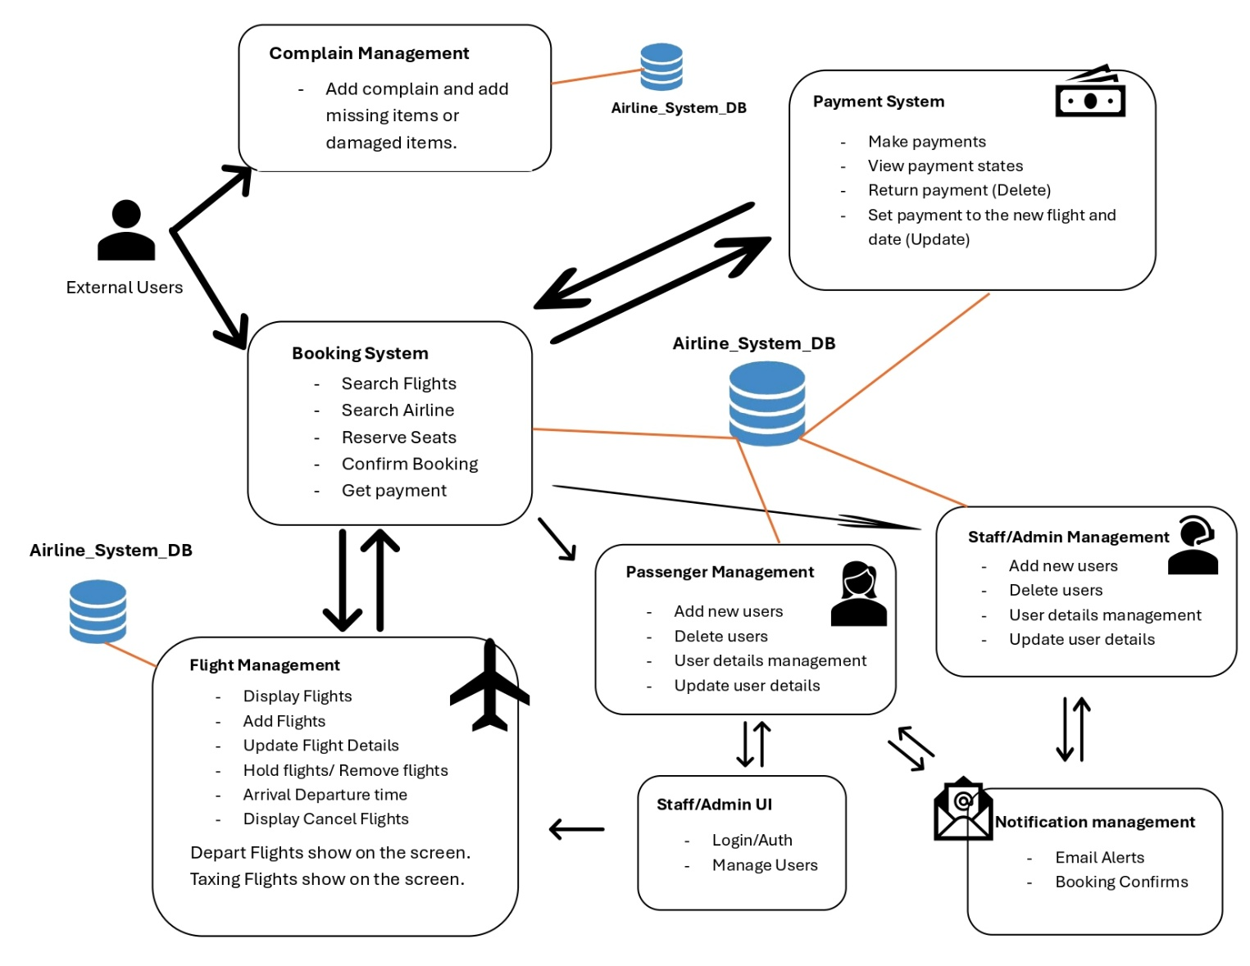
3.1 System Architecture Diagram

The diagram shows the system works and how works with each members.

3.2 Use Case Diagram
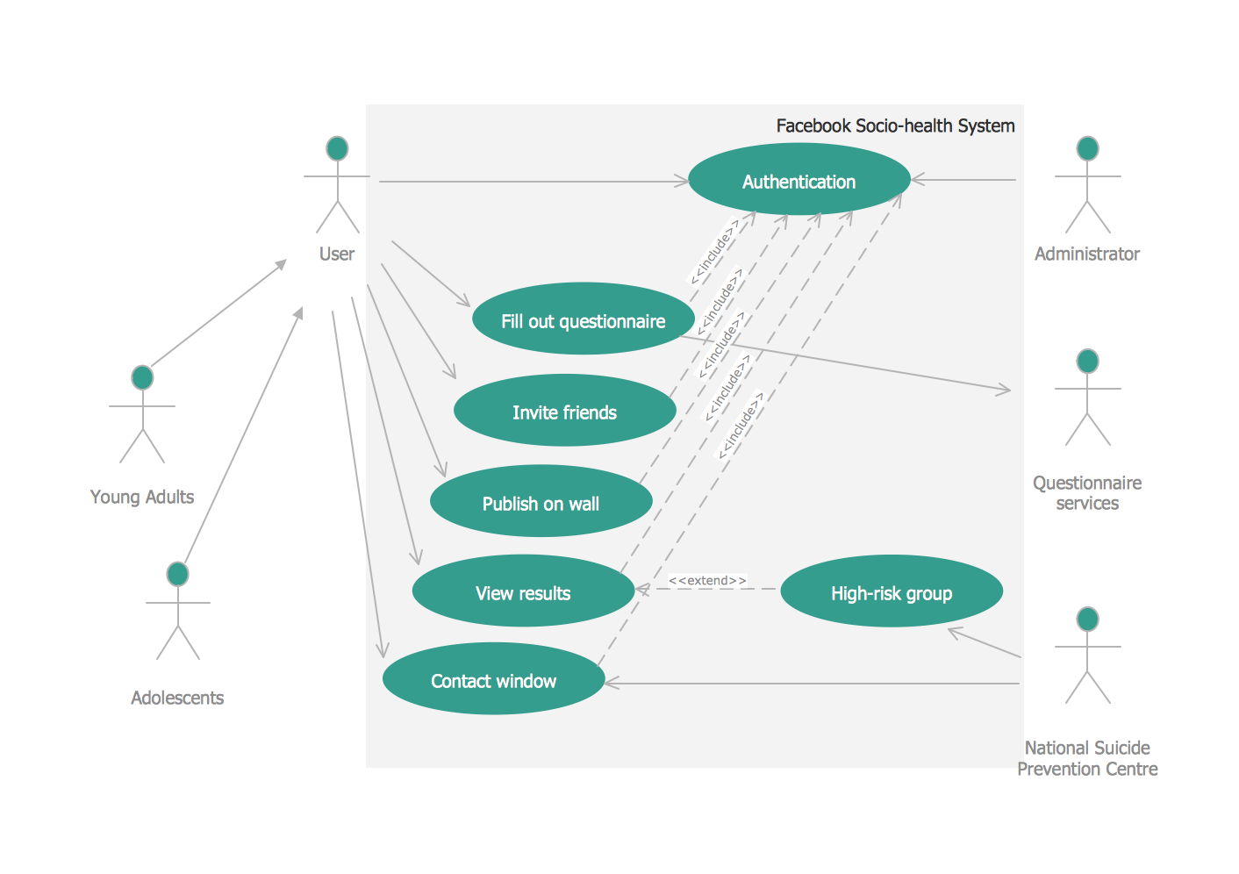

Total Actors: 6
Total Use Cases: 18

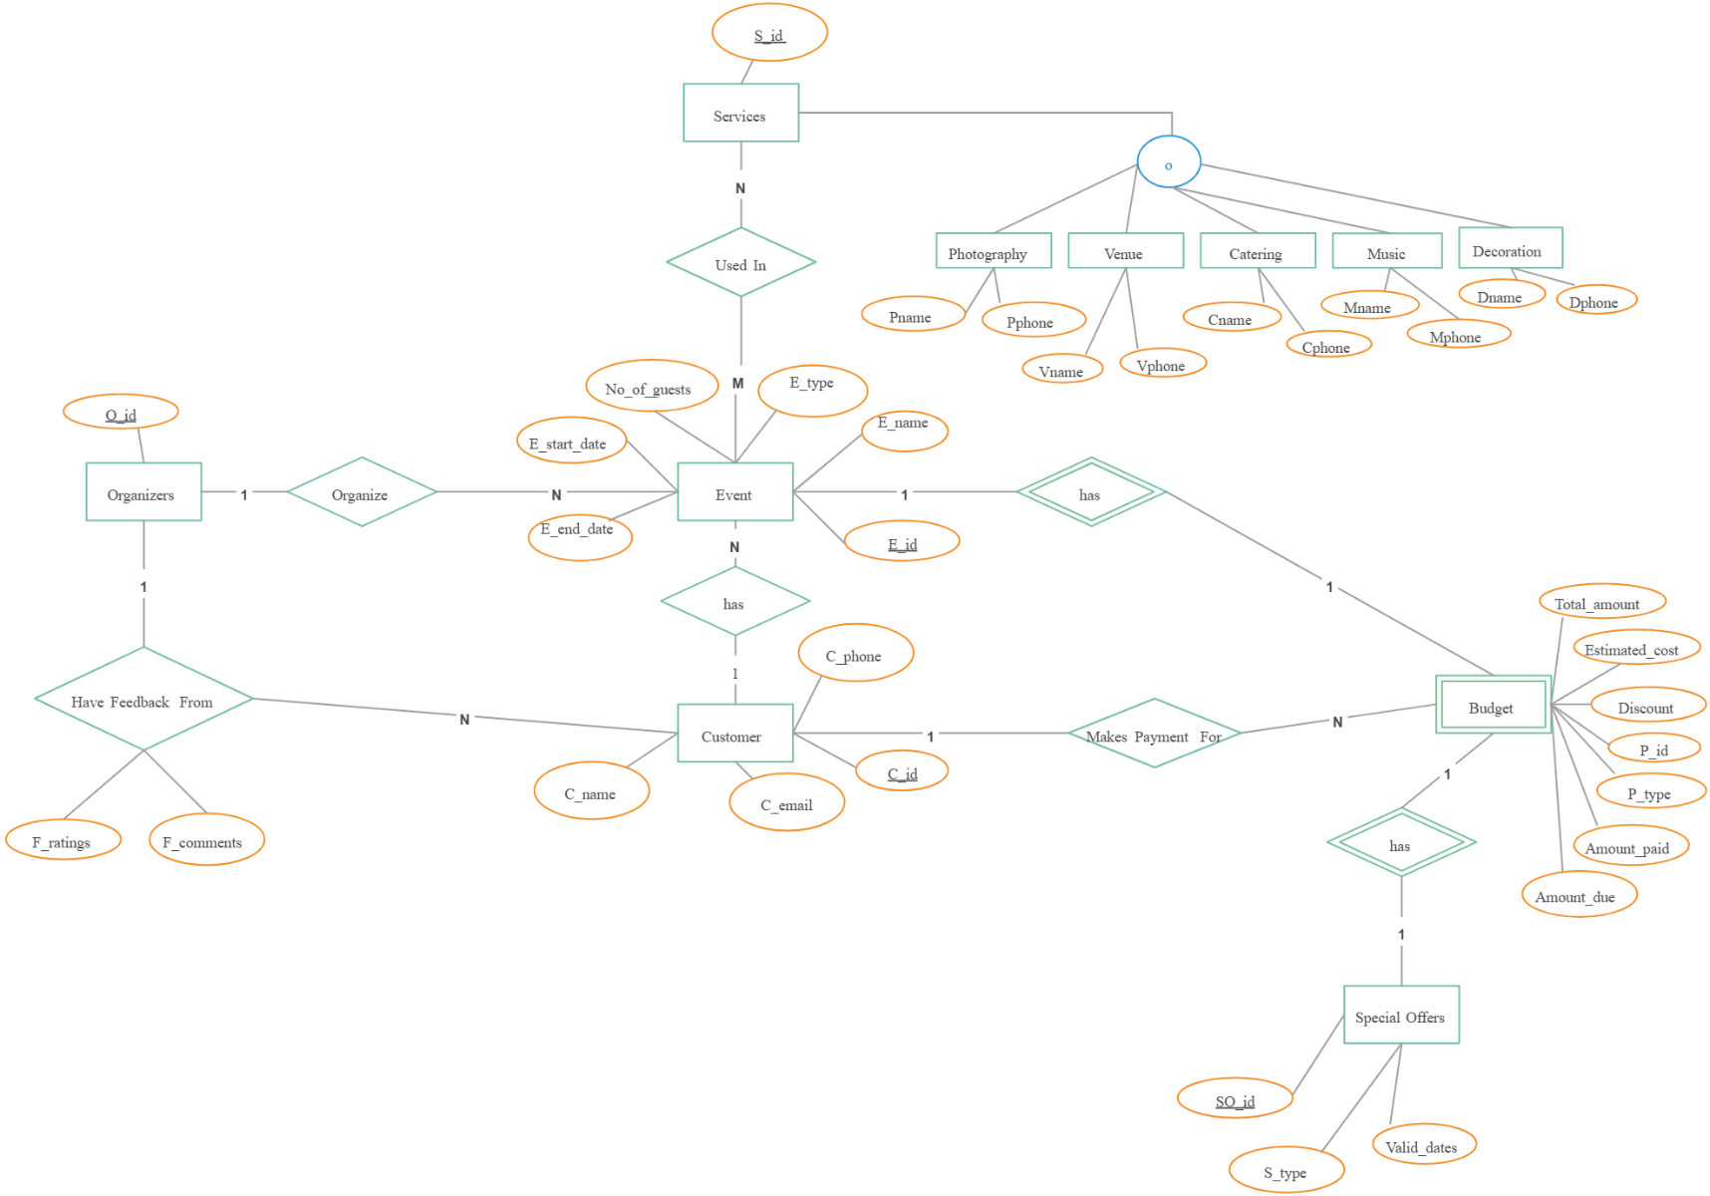
3.3 ER / EER Diagram

Total Entities: 12
Total Relationships: 5

3.4 Module-Level Diagrams
3.4.1 Client Module Use Case
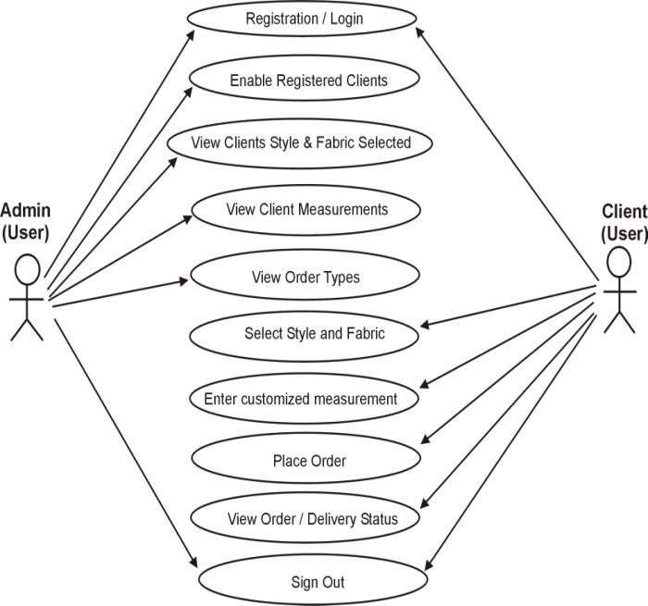

3.4.2 Event Manager Module Use Case
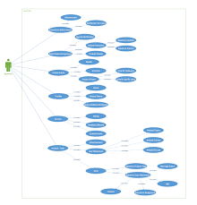

3.4.3 Vendor Module Use Case


3.4.4 Finance Module Use Case


3.4.5 Admin Module Use Case


3.4.6 Support Module Use Case



4. DESIGN SUMMARY

Total Entities: 18+
Total CRUD Modules: 6
Total UI Screens: 24+
Architecture: 3-Tier Web Architecture
Database: MySQL (Normalized to 3NF)
Backend: Spring Boot
Frontend: React
Security: JWT Authentication

5. CONCLUSION

The Smart Event Management System successfully implements six independent CRUD modules aligned with six stakeholders. Each member developed full-stack components including frontend, backend, database design, and testing.

============================================================

END OF REPORT

